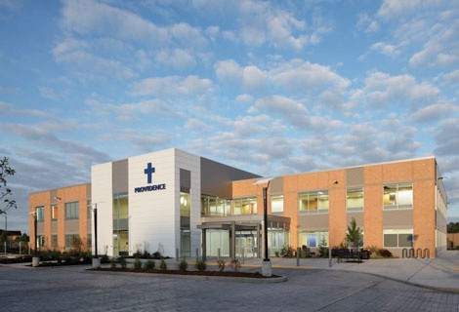

Providence Pharmacy Monroe

University of Washington PGY-1 Community Pharmacy Residency

A PGY-1 COMMUNITY RESIDENCY PROGRAM IN A CLINICAL AMBULATORY CARE SETTING

Prepares you for a clinical career

As a resident at Providence Pharmacy Monroe you will benefit from our unique training program that takes advantage of the wide array of learning experiences within both the community pharmacy and outpatient clinic setting. Our clinic incorporates the patient-centered medical home model, providing you with the opportunity to be a part of a progressive pharmacy team in a major west coast health care system.

Providence Pharmacy Monroe
Providence Pharmacy Monroe is located within Providence Medical Building Monroe in Monroe, Washington. It houses primary care, urgent care, and various specialty services including cardiology, ENT, OBGYN & midwifery, physiopathy, orthopedics, and general surgery.
PGY1 pharmacy residency programs build on Doctor of Pharmacy (Phar.D.) education and outcomes to contribute to the development of clinical pharmacists responsible for medication-related care of patients with a wide range of conditions, eligible for board certification, and eligible for postgraduate year two (PGY2) pharmacy residency training.
Pharmacist residency education and training in community-based practice aims to develop pharmacy leaders who are capable of improving the health of patients within the communities they serve.

As a part of the Providence Regional Medical Center Everett (PRMCE) network , the clinic pharmacy enjoys a close relationship with the two PRMCE hospitals in Everett located about 15 miles away. The clinic pharmacy is a professional outpatient pharmacy which also provides drug therapy management. Collaborative practice agreements encompass many clinical services including anticoagulation, diabetes management, immunizations, medication refill authorizations, and many more.

Providence Health & Services is one of the largest healthcare providers in the west with facilities in Alaska, Washington, Montana, Oregon, and California. One of the reasons new pharmacy school graduates and residents decide to join us is that our clinical setting allows them to practice direct patient care with the opportunity to develop strong practitioner-pharmacist relationships.
PGY-1 Community Pharmacy Residency Program accredited by ASHP and its partner, APhA

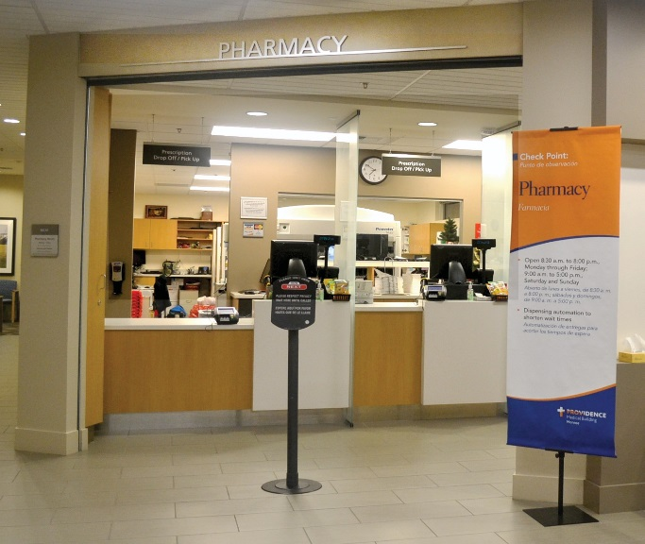

Clinical Care

- Anticoagulation monitoring
- Diabetes management
- Refill authorizations
- Complex medication review
- Transitional care services
- Medication therapy management
- Shared medical appointments
- Patient assistance program support
- Immunization administration
- In-services, continuing education, and newsletters
- Distribution services
- Physician consults

Administration
- Business and management concepts
- Manager meetings
- Pharmacy and Therapeutics Committee

Academics
- UW pharmacy resident seminars
- Teaching opportunities at the UW
- Precepting APPE pharmacy students
- Longitudinal residency projects
- Teaching certificate program
- Journal clubs

Elective Learning Opportunities
- Experiences based on individual interest

Resident must be a graduate of a college of pharmacy accredited by the American Council of Phar- maceutical Education and shall be licensed or eligible for licensure in the State of Washington. A Doctor of Pharmacy degree is preferred, but not required. The applicant shall meet all the require- ments for employment at Providence Regional Medical Center and meet the professional requirements of the Department of Pharmacy. In addition, the resident must possess excellent verbal and written communication skills, professionalism, leadership, and demonstrate a commitment to pharmaceutical care. Candidates for the pharmacy practice residency must participate in the ASHP resident matching program. All applications must be submitted via PHORCAS at https://portal.phorcas.org/

For more information visit http://sop.washington.edu/pharmres

